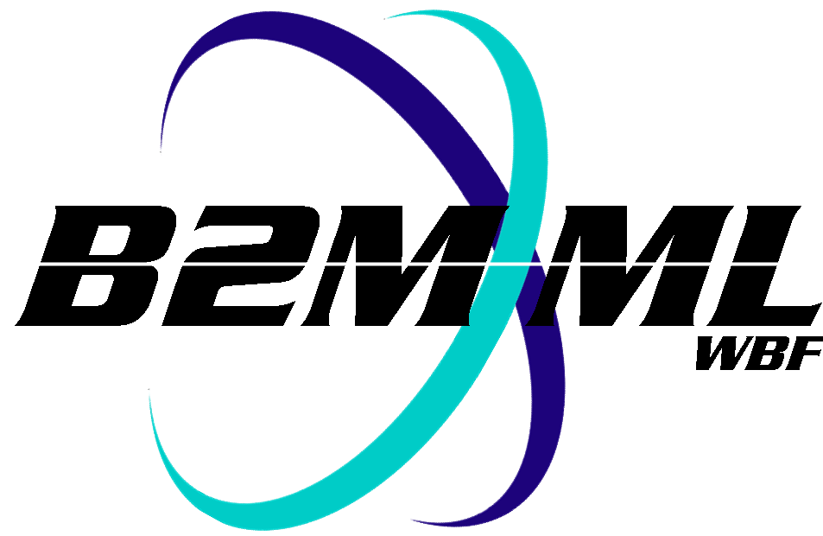
Business To Manufacturing
Markup Language
Batch Markup Language
Version 0500 – March 2011
Release Notes


IMPORTANT: While the information, data, and standards provided in this publication were developed and are presented in good faith in accordance with a reasonable process that was subject to intellectual property and antitrust policies to benefit the industry as a whole, the publication is provided “as is” for information and guidance only, and there is no representation or warranty of any type or kind, including but not limited to warranties of merchantability or fitness for a particular purpose, and no warranty that use of the information, data, or standards will not infringe patent, copyright, trademark, trade secret, or other intellectual property rights of any party.

The non-backward compatible changes to B2MML-V0500 from B2MML-V0401 are:
- Remove the ##any type from the schemas. This extension method has been superseded by the extended name space method.
- The “Location” element was changed to “HierarchyScope” to match the change to ANSI/ISA 95.02. The location element definition was kept in the common schema to support backward compatibility in the production schemas.
- Changed QA Test to Material Test to match the change to ANSI/ISA 95.02.
- In QualificationTestSpecificationType the element Name was changed to ID to match the change to ANSI/ISA 95.02.
- Added EquipmentLevel element to EquipmentType and EquipmentClassType to ID to match the change to ANSI/ISA 95.02.
- Removed EquipmentElementLevel from ProcessSegmentType (depreciated in Version 4.0).
- Made the UnitOfMeasure and DataType elements on QuantityType, ResultType, and ValueType optional. This is not strictly non—backward compatible, because previous schemas are still valid, but if an application was expecting to see these elements in a quantity, result, or value they can now be missing.

Backward compatible changes to B2MML-V0500.
- Extended the material elements to include the Assembly relationships defined in ANSI/ISA 95.02.
- Added the Operation objects. These include:
  - OperationsCapability
  - OperationsDefinition
  - OperationsPerformance
  - OperationsSchedule
- Added additional extension types for OperationsCapability, OperationsDefinition, OperationsPerformance, and OperationsSchedule so that there are unique and not combined with the ProductionCapability,ProductDefinition, ProductionPerformance, and ProductionSchedule extension elements. Operations elements type names and extension groups prefixed with “Op”.
- Addition of EquipmentModule and ControlModule to the EquipmentElementLevel type to support BatchML definitions.
- Added EquipmentAssetMapping element to the B2MML-V0500-Common.xsd to match the new element defined in ANSI/ISA 95.02.
- Added recursive property types (eg: PersonPropertyType, EquipmentPropertyType, …) to all property elements to match the change to ANSI/ISA 95.02.
- Removed multiple common schema elements in B2MML-V0500-Common.xsd that were only used in the removed maintenance schemas.
- Put the SegmentResponse element and all subelements in a separate file that is included by the ProductionSchedule and the ProductionPerformance schemas. This removed double duplication that was causing code generation problems in the .NET environment.
- Added the ChangeStatus elements to the ResponseCriteria element used in transactions. This provides elements that can contain the reason information for an acknowledge, response, or ConfirmBOD message.

- Added the Batch Production Record schemas.
- Included the ISA 95.02-2010 definitions of Physical Assets, OperationsDefinition, OperationsPerformance, and OperationsSchedule into the Batch Production Record.
- Added PhysicalAssetIDs into the Batch Production Record in the same elements that contained an EquipmentID element.

